0

THINKING OF BUILDING A KSD GREENHOUSE ON YOUR FARM OR IN YOUR YARD? CONTACT US!

KLINKMAN SOLAR DESIGN
Paul Klinkman or Liberty Goodwin
TELEPHONE: 401-351-9193
E-MAIL: info@klinkmansolar.com
WEBSITE: www.klinkmansolar.com

No obligation, no pressure. We will happily answer any questions you may have. We’ll help figure out whether our greenhouse might work for you, including cost, need and location factors. If you think you might like to become a KSD Greenhouse Builder, explore that with us. If you don’t want to build it yourself, but would like to have a KSD Greenhouse, we will help you find someone trained & licensed by us for the job.
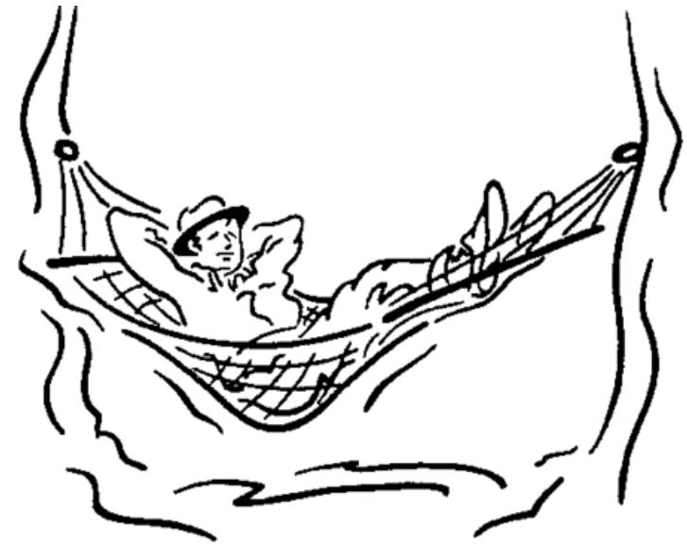
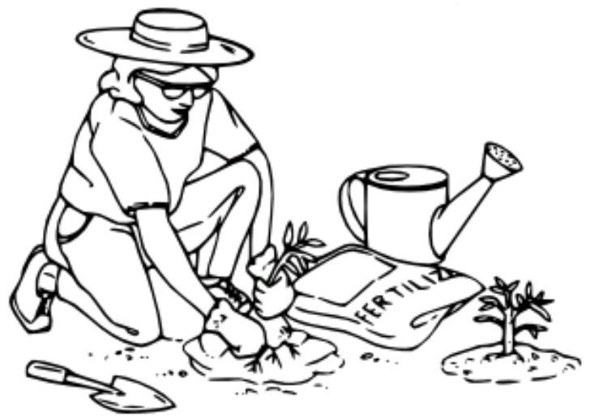

NOT JUST FOR FARMERS & GARDENERS! You can have a cozy, warm place to relax in winter, or vent the excess greenhouse heat into your home to reduce your fuel bills. (By the way, how come the only clip art I found shows the lady working & the guy lazing? Clearly he’s not a farmer!)

IT’S HERE! UNIQUE KSD SOLAR GREENHOUSE
BUILD-IT DESIGN PACKAGE FOR FARMERS
– AND INDEPENDENT CONTRACTORS

The package ncludes licensing for our patented design features, plans & drawings, instructions – and a real live savvy consultant to help you site and build. (Additional consulting time beyond the basic number will be available for an hourly fee.)

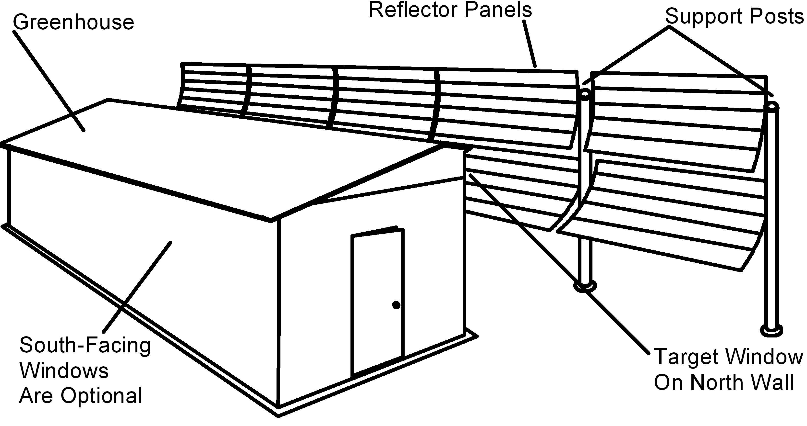

Patent #8408199, Paul Klinkman

ONE FARMER’S STATEMENT: As a production greenhouse grower and farmer here in RI, I think that anyone in the business would benefit by using the solar greenhouse. This project has really piqued my interest because I grow a lot of greenhouse vegetables and the heating cost is making it tougher to make a living, as it cuts right into the profit margin. I built all the greenhouses I have myself to help defray the cost. I believe that if this solar greenhouse could be built by the farmer, it would definitely be more cost effective and very popular with growers
(Art Mello, Mello’s Farm Stand, Portsmouth, RI).

KLINKMAN SOLAR DESIGN (KSD)

Paul Klinkman & Liberty Goodwin, Owners

Invention, Product Development, Training & Consulting
P.O. Box 40572, Providence, RI 02940
Tel. 401-351-9193. E-mail: info@klinkmansolar.com
Website: www.KlinkmanSolar.com

THE HISTORY OF THE KSD GREENHOUSE

KSD built a prototype sustainable greenhouse that kept tomato seedlings from freezing in the winter of 2010, with no fuel used.

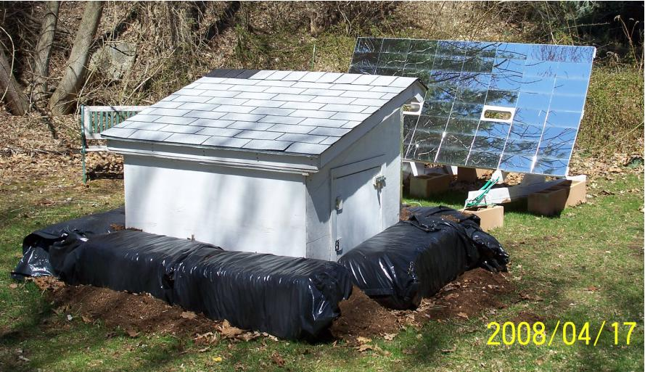
 BASICS: The greenhouse’s concentrating solar reflectors send heat and light through one row of windows on the north side of the structure. Insulation & thermal mass hold the heat at night.

2007 EXPERIMENTAL MODEL IN
N. SMITHFIELD, RI BACK YARD
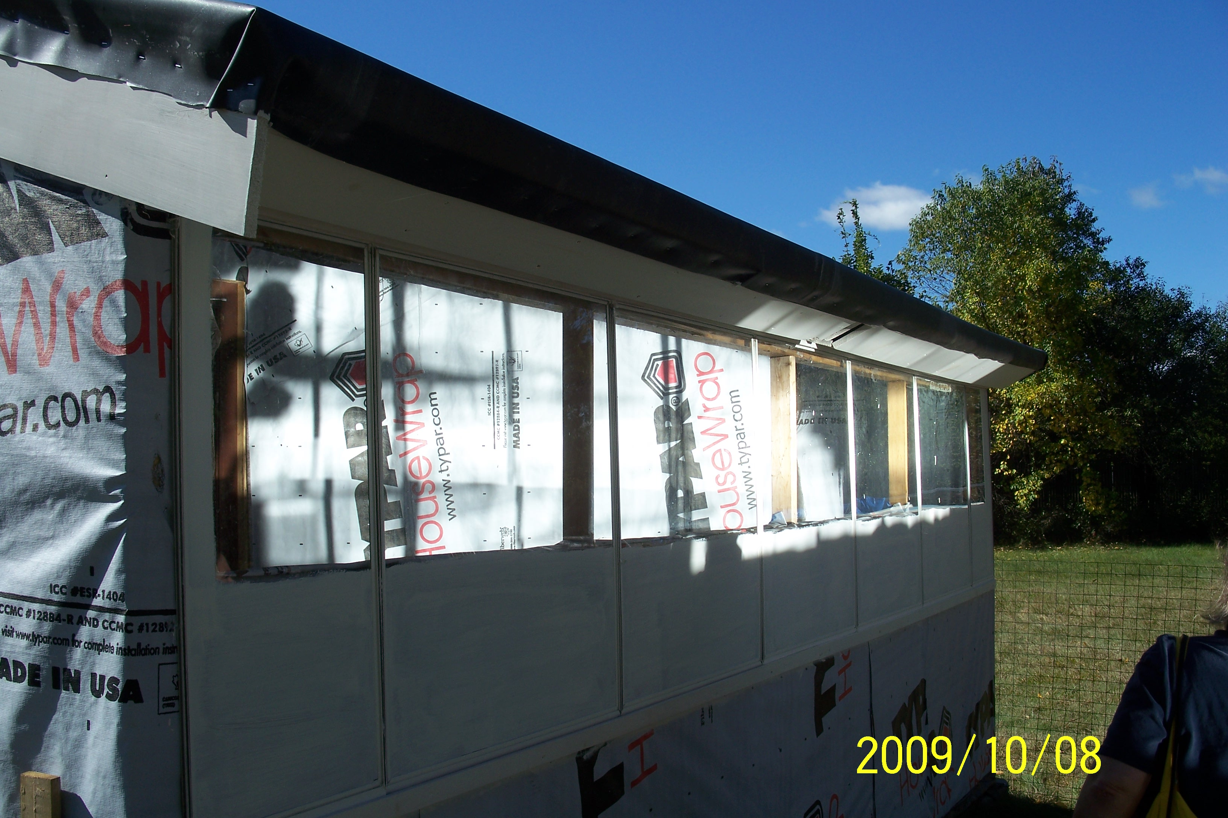
 A SUNNY SPACE: Our greenhouse’s linear reflecting trough keeps the reflected sun coming through the target window for most of the day. Inside, light spreads out to provide optimal strength sunlight on the plants
2008-2010 PROTOTYPE IN ATTLEBORO

 HEAT CONTROL: A heat-actuated vent door will pop open in the event of overheating – heat is actively blown outside. The Attleboro prototype made it through the winter of 2010 without any freezing, and we’ve added improvements since then.

 GROWING FACTORS: Our greenhouse can grow plants on supermarket-style shelves, for easy cart-to-shelf transfers. Our solar powered air circulation system simultaneously creates some air movement on the plants (avoiding mold problems) & stores the afternoon’s solar heat in concrete blocks underfoot. Grow lights use little solar/battery power & extend the types of crops that we can grow. Primary products are perishable warm-weather vegetables in winter and live plants for spring planting.

WHAT WE’LL DO

 PROVIDE A KSD DESIGN PACKAGE KIT THAT WILL ALLOW FARMERS AND OTHER HANDY PEOPLE TO BUILD THEIR OWN GREENHOUSES

 INCLUDE EXPERT CONSULTATION & TECH SUPPORT TO ASSIST THEM THROUGHOUT THE PROCESS OF BUILDING..

 TRAIN PEOPLE TO DO ON-SITE ASSISTANCE OR BECOME KSD-LICENSED BUILDERS.

 TRAIN & LICENSE LOCALLY OWNED SMALL BUSINESSES TO MANUFACTURE DESIRED PARTS, SUCH AS PREMIUM SOLAR CONCENTRATING COLLECTORS.

 WORK TO DEVELOP A NETWORK OF LOCAL RESOURCES THAT COULD MARKET, MANUFACTURE & INSTALL GREENHOUSES. SOME MIGHT ALSO PRODUCE & SELL BIOFUEL FROM ALGAE.

 INCLUDE NON-PROFIT ORGANIZATIONS, AS PARTNERS THAT COULD RAISE MONEY FROM SELLING THE KITS & SUBSIDIZE OR GIVE UNITS TO COMMUNITY GARDENS, FOOD BANKS, ETC.)

 DEVELOP A RESIDENTIAL VERSION THAT COULD PROVIDE GARDENING & SUN SPACE, AS WELL AS SUPPLEMENTARY HEAT TO AN ADJACENT HOUSE.

LOCAL JOBS, LOCAL FOOD, A FLOURISHING LOCAL ECONOMY – THAT’S OUR GOAL!

KLINKMAN SOLAR DESIGN
Paul Klinkman & Liberty Goodwin, Owners

A PARTNERSHIP FOR SUSTAINABILITY AND THE SUPPORT OF LOCAL FARMING & SMALL BUSINESS

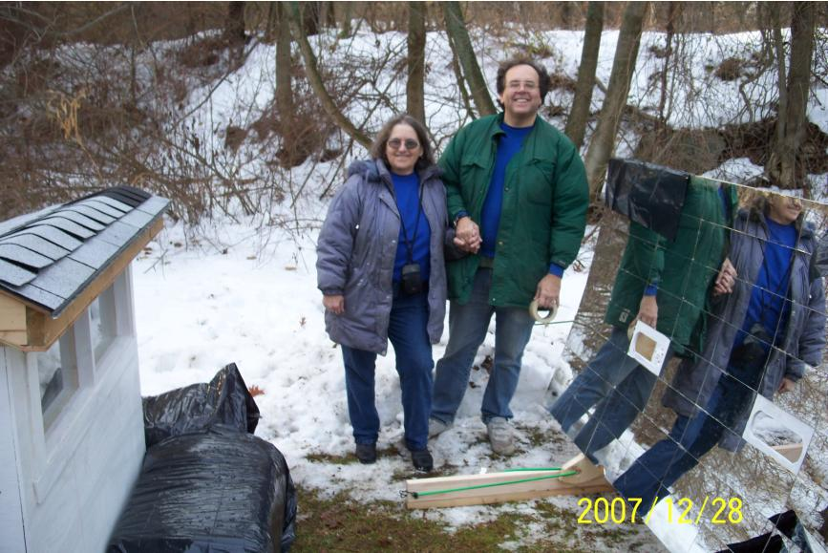

OUR UNIQUE BUSINESS PLAN

Our goal is to find ways to make truly innovative, non-polluting, sustainable & effective energy options available to all. We will offer flexible, cost-sensitive means for farmers, community organizations, schools, and low income people to benefit from Paul’s inventions.

The first move in this work is the new Build-It model, by which farmers can obtain a greenhouse without going into significant debt, produce more crops over the year, and avoid large fossil fuel costs for heating.

Next, we’ll train individuals to be KSD builders – as independent business people, they can market, assist farmers to build, or build greenhouses for others.

OUR NEWLY PATENTED GREENHOUSE SOLVES

INDUSTRY PROBLEMS, HAS UNIQUE ADVANTAGES:

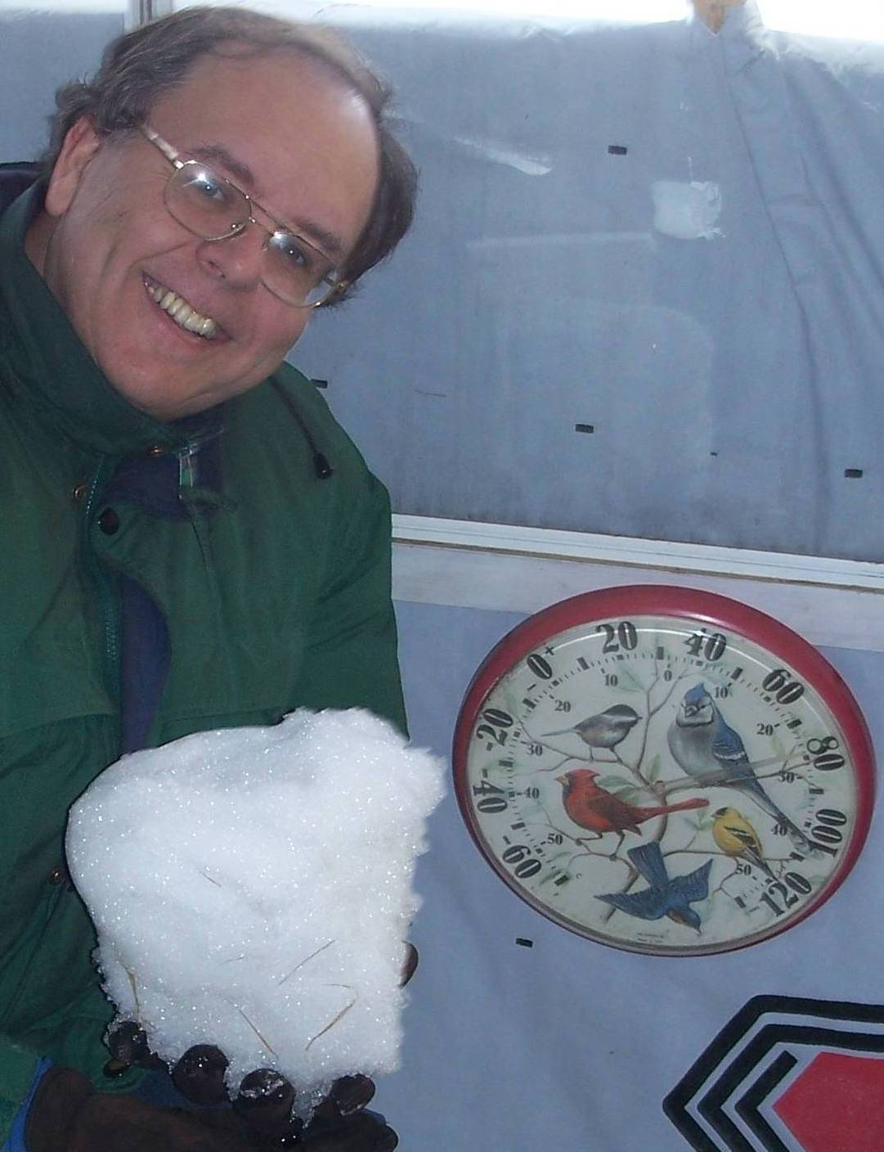
GROWING TIME – UP,
HEATING COST – DOWN!
CONSTRUCTION COST – VERY LOW!

The original, revolutionary design has been improved. Get a sturdy, state-of-the-art greenhouse with concentrated sunlight and low heat loss at night over the winter, for little money down and a solid return on investment

Here is Paul inside the greenhouse prototype with a snowball from outside, next to a thermometer reading 78 degrees.

 Surprisingly low construction costs – you can build it.
 Near-zero annual operating cost, for both cool and hot weather crop options.
 Long-lasting. Safe in high wind gusts, no expensive plastic that can slash and freeze the crop
 Productive. An optimum intensity of sunlight reaches the crops in winter. The greenhouse’s linear reflecting trough keeps reflected sun on target for most of the day. Light concentrated through the window spreads out inside.
 Ergonomic vertical growing space. A 20’ x 12’ greenhouse delivers 100 square feet of direct sunlight onto a vertical wall of crops.
 Photovoltaic-powered fan air movement reduces leaf mold issues.
 Higher indoor temperatures can reduce humidity
 Better sunshine from non- optimal greenhouse locations
 Crops can survive brutally hot summer afternoons by repointing the reflectors.

KSD SOLAR GREENHOUSE COST FACTORS

LICENSE, PLANS & CONSULTING

Up-front cost for the package will be flexible, and is expected to range from around $1,000 to $2,000, including 10 to 15 hours training/consulting time. An hourly rate will be charged for work beyond the initial time. (Factors considered: size of farm, non-profit use, complexity of the desired structure, etc.)

COSTS & SPECS

The most significant cost savings can be realized by:

1. The “sweat equity” of the buyer - construction labor is expensive.

2. The thousands of dollars of fuel costs saved vs. paying to heat a conventional greenhouse with fossil fuel through the cold months.

Our smallest greenhouse is 20’ east-west by 12’ north-south. The reflector assembly is erected 10’ from the greenhouse’s north wall and is 24’ long.

The price of materials for this greenhouse is $4200 at major store prices. However, farmers may want to scrounge for lumber, window glass and standard concrete blocks when possible.

Mirrors $250 Window Glass $300
Lumber $1000 Insulation $400
Concrete blocks $500 Roofing $200
Solar panel $300 Fan $150

**************************************************************
CONSTRUCTION FEATURES

 The greenhouse is ten feet tall. The building’s construction isn’t particularly specialized.
 Our greenhouses adjust to warmer and to colder climates and changing weather conditions.
 Our standard greenhouse comes with its own 24-volt photovoltaic electrical system that runs the fan to adapt to high heat conditions.
 You’ll need water for winter growing. You’ll want to bury a cold water pipe to the greenhouse.
 It may be a “temporary” greenhouse for zoning purposes, designed without a foundation and without a household electrical current line.
 Straw bale construction should work.
 We have an algae growing option.
 Our reflectors are sturdy and wind-resistant. Moreover, individual mirrors can easily be replaced if broken – for about $1.50.
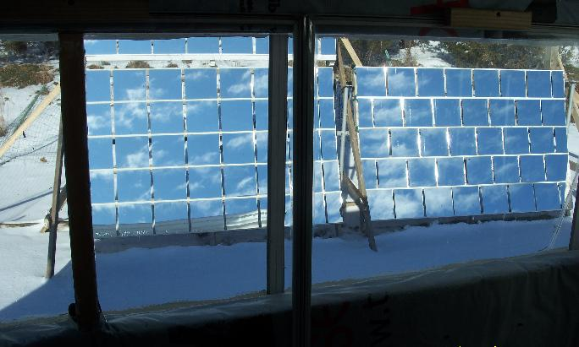

VIEW OF SOLAR REFLECTORS FROM
INSIDE A GREENHOUSE “WINDOW WALL”

